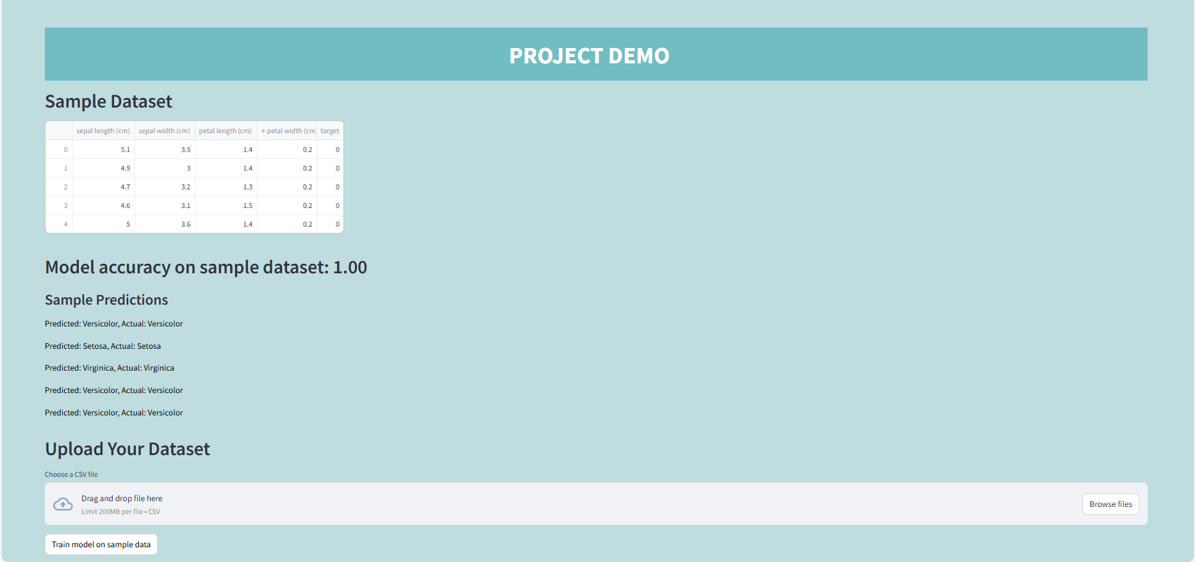

Code

import streamlit as st

import pandas as pd

from sklearn.datasets import load_iris

from sklearn.model_selection import train_test_split

from sklearn.preprocessing import StandardScaler

from sklearn.linear_model import LogisticRegression

from sklearn.metrics import accuracy_score

# Function to load data

def load_data():

    data = load_iris()

    df = pd.DataFrame(data.data, columns=data.feature_names)

    df['target'] = data.target

    return df

# Function to train model and return predictions

def train_model(df):

    X = df.drop('target', axis=1)

    y = df['target']

    X_train, X_test, y_train, y_test = train_test_split(X, y, test_size=0.3, random_state=42)

    scaler = StandardScaler()

    X_train_scaled = scaler.fit_transform(X_train)

    X_test_scaled = scaler.transform(X_test)

    model = LogisticRegression()

    model.fit(X_train_scaled, y_train)

    y_pred = model.predict(X_test_scaled)

    accuracy = accuracy_score(y_test, y_pred)

    return model, accuracy, y_pred, y_test

# Set up the Streamlit app

st.set_page_config(page_title="Machine Learning Pipeline Demo", layout="wide")

# CSS to set background color

page_bg_color = '''

<style>

[data-testid="stAppViewContainer"] {

    background-color: #BFDDDF;  /* Change this to your desired background color */

    color: black;

}

</style>

'''

st.markdown(page_bg_color, unsafe_allow_html=True)

# App title and description

st.markdown(

    """

    <div style="background-color: #70BDC2; padding: 5px;">

        <h1 style="text-align: center; color: white;">PROJECT DEMO</h1>

    </div>

    """,

    unsafe_allow_html=True,

)

# Display sample dataset

df = load_data()

st.write("## Sample Dataset")

st.write(df.head())

# Train and display model accuracy on the sample dataset

model, accuracy, y_pred, y_test = train_model(df)

st.write(f"## Model accuracy on sample dataset: {accuracy:.2f}")

# Map the numerical labels to species names

species_mapping = {0: 'Setosa', 1: 'Versicolor', 2: 'Virginica'}

y_pred_names = [species_mapping[label] for label in y_pred]

y_test_names = [species_mapping[label] for label in y_test]

# Display some sample predictions

st.write("### Sample Predictions")

for i in range(5):

    st.write(f"Predicted: {y_pred_names[i]}, Actual: {y_test_names[i]}")

# File uploader for user dataset

st.write("## Upload Your Dataset")

uploaded_file = st.file_uploader("Choose a CSV file", type="csv")

if uploaded_file is not None:

    user_df = pd.read_csv(uploaded_file)

    st.write("### Uploaded Dataset")

    st.write(user_df.head())

    # Check if the uploaded dataset has the necessary columns

    if set(df.columns).issubset(user_df.columns):

        user_model, user_accuracy, user_y_pred, user_y_test = train_model(user_df)

        user_y_pred_names = [species_mapping[label] for label in user_y_pred]

        user_y_test_names = [species_mapping[label] for label in user_y_test]

        st.write(f"### Model accuracy on uploaded dataset: {user_accuracy:.2f}")

        # Display some sample predictions on user data

        st.write("### Sample Predictions on Uploaded Data")

        for i in range(5):

            st.write(f"Predicted: {user_y_pred_names[i]}, Actual: {user_y_test_names[i]}")

    else:

        st.write("The uploaded dataset does not have the required columns.")

# Add a button to train the model on sample data

if st.button("Train model on sample data"):

    model, accuracy, y_pred, y_test = train_model(df)

    st.write(f"Model accuracy on sample dataset: {accuracy:.2f}")

# Add a button to train the model on user data

if uploaded_file is not None:

    if st.button("Train model on uploaded data"):

        user_model, user_accuracy, user_y_pred, user_y_test = train_model(user_df)

        user_y_pred_names = [species_mapping[label] for label in user_y_pred]

        user_y_test_names = [species_mapping[label] for label in user_y_test]

        st.write(f"Model accuracy on uploaded dataset: {user_accuracy:.2f}")

        # Display some sample predictions on user data

        st.write("### Sample Predictions on Uploaded Data")

        for i in range(5):

            st.write(f"Predicted: {user_y_pred_names[i]}, Actual: {user_y_test_names[i]}")